DBSCAN:
- DBSCAN stands for Density-Based Spatial Clustering of Applications with Noise, which is an unsupervised learning algorithm.

- DBSCAN is one of the most widely used clustering methods because the clusters found by DBSCAN can be any shape, which can deal with some special cases that other methods cannot.

- One of the most used examples to show the advantage of DBSCAN over the K-means clustering algorithm is the following plot.
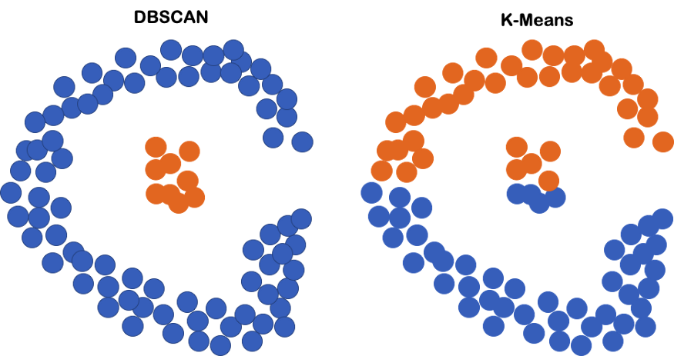
DBSCAN vs K-means. Dots are samples, the X-axis is feature 1 and the Y-axis is feature 2.
- In the example above, the linear boundary of the k-means clustering definitely does not work well.
- However, DBSCAN doesn’t require any shape of the clusters but tracks the high-density regions, which is more suitable than k-means in the situation.

Understanding DBSCAN

- From the name of DBSCAN, we can obviously tell that the most important part is the word “density-based”.
- So, what is density? Straightforwardly, we can understand density as a measure of the number of data points in a specified area.
- Then, how to describe a “specified area”? We can use a center point with a certain value of the distance from it to describe a specified area.
- So, the clusters in DBSCAN are those “specified areas” of a high number of data points (dense area).
- In the description above, we find that several “terms” are very important for the clustering process.
- First, “a certain value of the distance”. What is the value? How do we measure the value of distance?
- Second, “a center point”. What is a center point to define those “specified areas”?
- Third, “a high number of data points”. How to define “high number”?
- Actually, all the parameters in DBSCAN have been mentioned in the questions above.
- First, eps, the maximum distance between two samples for one to be considered to be connected to the other. And the distance can be defined by any type of distance function, the “Euclidean distance” for example.
- Second, core samples, the samples that are in areas of high density.
- Third, minPts, the minimum number of samples in a neighborhood for a point to be considered as a core point.
- These parameters altogether define the type of a data point in DBSCAN clustering.
- The points are classified as core points, reachable points, and outliers.
- Alright, with these concepts in mind, let’s look at a specific example to go over the idea of DBSCAN.
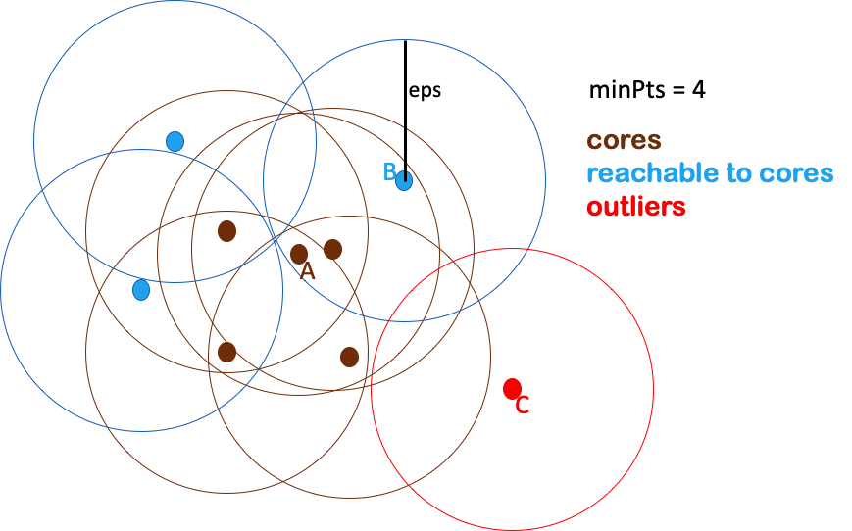
- Example of cores, reachable points to cores, and outliers in DBSCAN.

- In the plot above, we set minPts as 4, which means a point is called a core point if at least 4 points (including itself) are within distance eps of it.

- So, A is a core point and all the other brown points are core points as well because all of them have at least 4 points within eps surrounding them.

- Even though the blue points, such as B, are not core points because of less than 4 neighborhood points within eps, they can still be directly reachable from certain core points.

- So, they belong to the same cluster of those core points.

- However, point C can not be reachable from any core point, so it’s called an outlier.

- From the example above, we can see that the clusters in DBSCAN consist of core points as well as non-core points that are reachable from the core points.

- And each cluster contains at least one core point.

- Even though a non-core point can also be one part of a cluster, it can only be at the boundaries of the cluster because they themselves cannot reach more points.

The DBSCAN Algorithm
- Alright, after understanding the idea of DBSCAN, let’s summarize the DBSCAN algorithm in the following steps,

- For each data point, find the points in the neighborhood within eps distance, and define the core points as those with at least minPts neighbors.

- Define groups of connected core points as clusters.

- Assign each non-core point to a nearby cluster if it’s directly reachable from a neighboring core point, otherwise define it as an outlier.

- A large eps tend to include more points within a cluster, so a too-large eps will include everything in the same single cluster and a too-small eps will result in no clustering at all.
- A too-small minPts is not meaningful because it will regard every point as a core point. A relatively larger minPts can be better to deal with data with more noises.

The Advantages of DBSCAN
- After knowing the idea and the algorithm of DBSCAN, its advantages are very obvious.
- First, DBSCAN doesn’t require users to specify the number of clusters.
- Second, DBSCAN is NOT sensitive to outliers.
- Third, the clusters formed by DBSCAN can be any shape, which makes it robust to different types of data.

- But no unsupervised algorithm is perfect. DBSCAN does have its limitations. For example, it would be a big concern to use DBSCAN if the data has a very large variation in densities across clusters because you can only use one pair of parameters, eps and MinPts, on one dataset.
- In addition, it could be super hard to define eps without the domain knowledge of the data.

The Implementation in Python
The implementation of DBSCAN in Python can be achieved by the scikit-learn package. The code to cluster data X is as below,
from sklearn.cluster import DBSCAN
import numpy as np
DBSCAN_cluster = DBSCAN(eps=10, min_samples=5).fit(X)

where min_samples is the parameter MinPts and eps is the distance parameter.
If you want to check the clustering result of the data, you can use the command below,
DBSCAN_cluster.labels_

//2nd method

Introduction

DBSCAN algorithm works with two parameters.
These parameters are:
- Epsilon (Eps): This is the least distance required for two points to be termed as a neighbor. This distance is known as Epsilon (Eps). Thus we consider Eps as a threshold for considering two points as neighbors, i.e., if the distance between two points is utmost Eps, then we consider the two points to be neighbors.
- MinPoints: This refers to the minimum number of points needed to construct a cluster. We consider MinPoints as a threshold for considering a cluster as a cluster. A cluster is only recognized if the number of points is greater than or equal to the MinPts.
We classify data points into three categories based on the two parameters above. So let us look at these categories.

Types of data points in a DBSCAN clustering
After the DBSCAN clustering is complete, we end up with three types of data points as follows:
- Core: This is a point from which the two parameters above are fully defined, i.e., a point with at least Minpoints within the Eps distance from itself.
- Border: This is any data point that is not a core point, but it has at least one Core point within Eps distance from itself.
- Noise: This is a point with less than Minpoints within distance Eps from itself. Thus, it’s not a Core or a Border.
Let’s now look at the algorithmic steps of DBSCAN clustering.

DBSCAN algorithm
The following are the DBSCAN clustering algorithmic steps:
- Step 1: Initially, the algorithms start by selecting a point (x) randomly from the data set and finding all the neighbor points within Eps from it. If the number of Eps-neighbours is greater than or equal to MinPoints, we consider x a core point. Then, with its Eps-neighbours, x forms the first cluster.
After creating the first cluster, we examine all its member points and find their respective Eps -neighbors. If a member has at least MinPoints Eps-neighbours, we expand the initial cluster by adding those Eps-neighbours to the cluster. This continues until there are no more points to add to this cluster.
- Step 2: For any other core point not assigned to cluster, create a new cluster.
- Step 3: To the core point cluster, find and assign all points that are recursively connected to it.
- Step 4: Iterate through all unattended points in the dataset and assign them to the nearest cluster at Eps distance from themselves. If a point does not fit any available clusters, locate it as a noise point.

Python implementation of DBSCAN
As usual to any implementation, we get started with fetching the dataset and preparing it ready for our model implementation. However, first, let us download this data here.

Data Preprocessing

Importing the required libraries
Let us begin by importing the required libraries for implementation on the algorithm.
import numpy as np
import matplotlib.pyplot as plt
import pandas as pd
data = pd.read_csv("/content/drive/MyDrive/Mall_Customers.csv") # importing the dataset

Exploratory data analysis
This is the process of investigating the available data and determining inconsistencies in patterns and other anomalies with the help of graphical representations and statistical summaries.
- Checking the head of the data.
data.head()
- Output
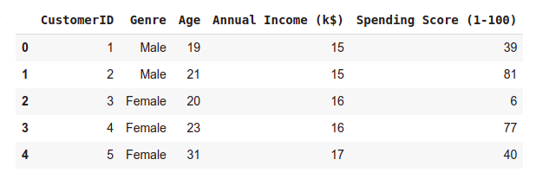
- Checking the shape of the dataset.
print("Dataset shape:", data.shape)

Output
Dataset shape: (200, 5)
Next, we check if the dataset has any missing values.
# checking for NULL data in the dataset
data.isnull().any().any()

Output
False
The above output means there are no missing values in our dataset. Since our data is ready to use, let us extract the Annual Income and the Spending Score columns and apply our DBSCAN model to them.
# extracting the above mentioned columns
x = data.loc[:, ['Annual Income (k$)',
'Spending Score (1-100)']].values

- Let us check the shape of x.
print(x.shape)

Output
(200, 2)

Before we apply the DBSCAN model, first, we need to obtain its two parameters.
- MinPoints: We can obtain the minimum number of Points to be used to recognize a cluster, as follows:
- If the dataset has two dimensions, use the min sample per cluster as 4.
- If the data has more than two dimensions, the min sample per cluster should be: Min_sample(MinPoints) = 2 * Data dimension
Since our data is two-dimensional, we shall use the default value of 4 as our MinPoint parameter.
- Epsilon (Eps): To calculate the value of Eps, we shall calculate the distance between each data point to its closest neighbor using the Nearest Neighbours. After that, we sort them and finally plot them. From the plot, we identify the maximum value at the curvature of the graph. This value is our Eps.

Compute data proximity from each other using Nearest Neighbours
from sklearn.neighbors import NearestNeighbors # importing the library
neighb = NearestNeighbors(n_neighbors=2) # creating an object of the NearestNeighbors class
nbrs=neighb.fit(x) # fitting the data to the object
distances,indices=nbrs.kneighbors(x) # finding the nearest neighbours

Sorting and plot the distances between the data points
# Sort and plot the distances results
distances = np.sort(distances, axis = 0) # sorting the distances
distances = distances[:, 1] # taking the second column of the sorted distances
plt.rcParams['figure.figsize'] = (5,3) # setting the figure size
plt.plot(distances) # plotting the distances
plt.show() # showing the plot

Output

Executing the code above, we obtain the following plot:
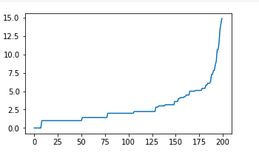
From the above plot, we note the maximum curvature of the curve is about eight, and thus we picked our Eps as 8.

We now have our two parameters as:

MinPoints = 4

Eps = 8
Now that we have the parameters let us implement the DBSCAN model.

Implementing the DBSCAN model
from sklearn.cluster import DBSCAN
# cluster the data into five clusters
dbscan = DBSCAN(eps = 8, min_samples = 4).fit(x) # fitting the model
labels = dbscan.labels_ # getting the labels
# Plot the clusters
plt.scatter(x[:, 0], x[:,1], c = labels, cmap= "plasma") # plotting the clusters
plt.xlabel("Income") # X-axis label
plt.ylabel("Spending Score") # Y-axis label
plt.show() # showing the plot

Clusters plot
